
Catherine Adams
615-556-7246
Catherine.Adams05@gmail.com
CG Generalist
Breakdown Sheet
CatieAdams.com


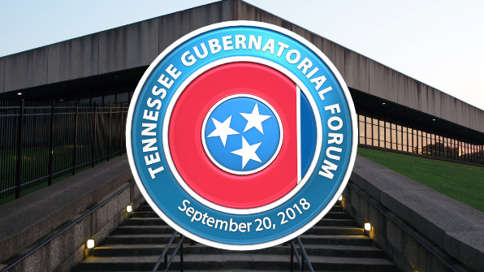
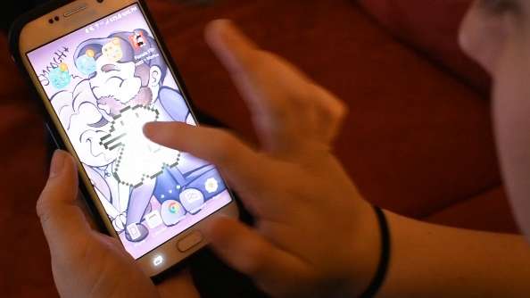
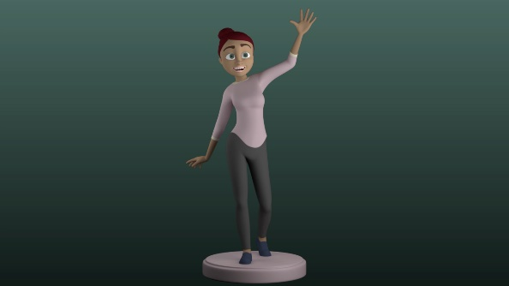
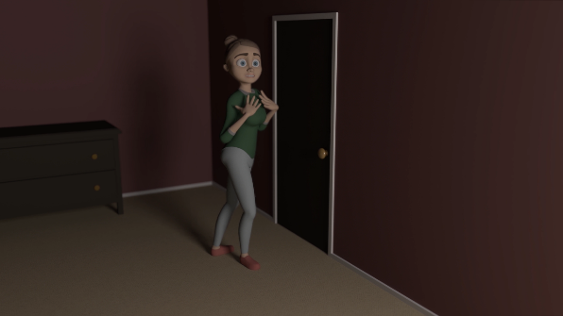
5. Governor’s Debate – Lower Thirds
Programs: Illustrator, Cinema 4D, After Effects
My Work: 3D version of Logo; Text Creation; Animating
4. Governor’s Debate – Logo
Programs: Illustrator, Cinema 4D, After Effects
My Work: 3D Version of Logo; Animation; Camera Control
My Work: Character Design for Tamagotchi; Tamagotchi Animation; Screen Replacement using Mocha and After Effects
Programs: Photoshop, After Effects
My Work: Character Design; Modeling; Texturing; Rigging
Programs: Maya, After Effects
Page 1
3. Haunting Tamagotchi
2. Darcie Turnaround

My Work: Character Design; Modeling; Texturing; Rigging; Animating
Programs: Maya, Premiere
1. Lip Sync – “I like to watch you sleep”
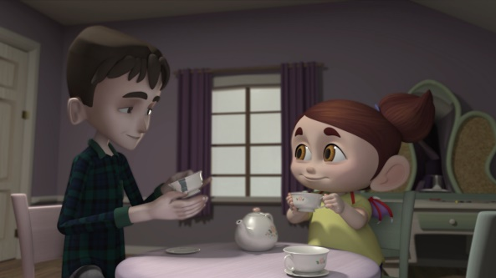
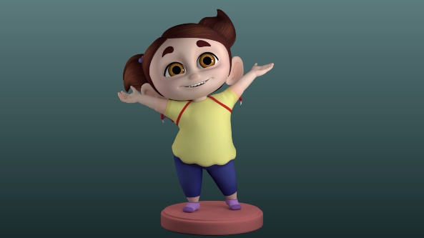
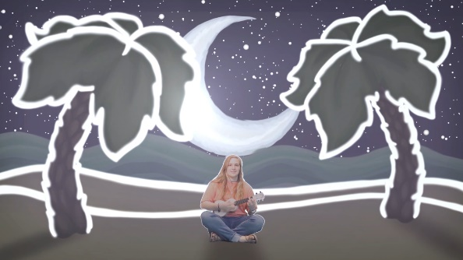
t
8. Monstrosi-TEA Shots 8 and 14
Programs: Maya, After Effects, Premiere
My Work: Character Design, Modeling, and Rigging with Advanced Skeleton for the girl; Modeled the chairs, tea cups, dresser, toy shelf, vanity, and its contents; Environment Layout; Lighting; Animation on all characters; Cinematography; Compositing; Editing
This is my senior short film. I co-created this film with Ansley Pearson. It is about the way people are perceived based on their actions towards us. To see the full film: https://vimeo.com/333905365 Password: sloth&crow
My Work: Music; Created all background pieces in Photoshop; Animation
Programs: Photoshop, After Effects, Premiere
6. Wonderful World
Catherine Adams
615-556-7246
Catherine.Adams05@gmail.com
CG Generalist
Breakdown Sheet
CatieAdams.com

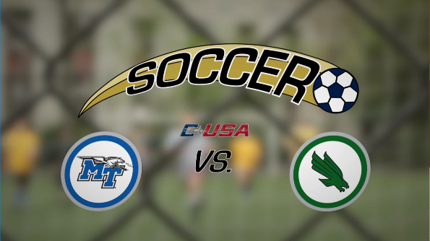
9. Soccer – Title
Programs: Illustrator, After Effects
My Work: Soccer Logo; Animation
To see her in action, check out the film I co-created with Ansley Pearson: https://vimeo.com/333905365 Password: sloth&crow
Programs: Maya, After Effects
7. Sally Turnaround
My Work: Character Design; Modeling; Rigged with Advanced Skeleton
Page 2
t
Catherine Adams
615-556-7246
Catherine.Adams05@gmail.com
CG Generalist
Breakdown Sheet
Website…

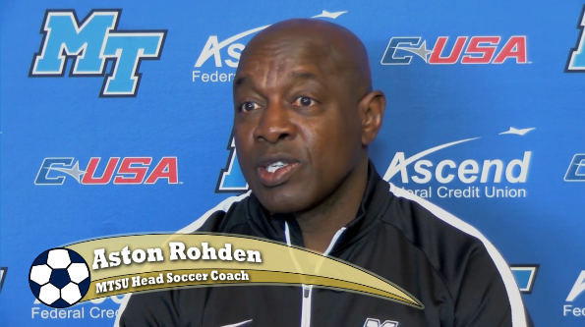
My Work: Soccer Logo; Lower thirds design; Animation
Programs: Illustrator, After Effects
10. Soccer – Lower Thirds
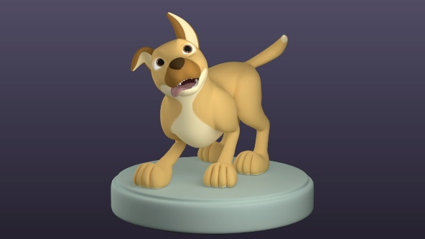
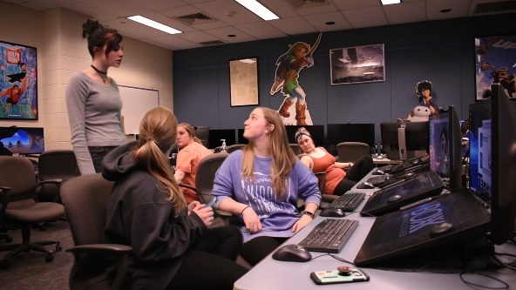
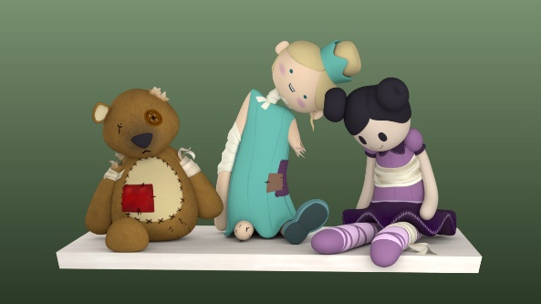
13. Puppy Turnaround
Programs: Maya, After Effects

My Work: Modeling; Rigged with Advanced Skeleton
12. A Lot of Me’s
Programs: After Effects
My Work: Two Background me’s are split screen; Midground me and other girl and Foreground me were shot on green screen; Keyed and masked in After Effects
11. Toys Turnaround
Programs: Maya, After Effects

My Work: Design; Modeling

Page 3

